HUNDRED SUNS WINE

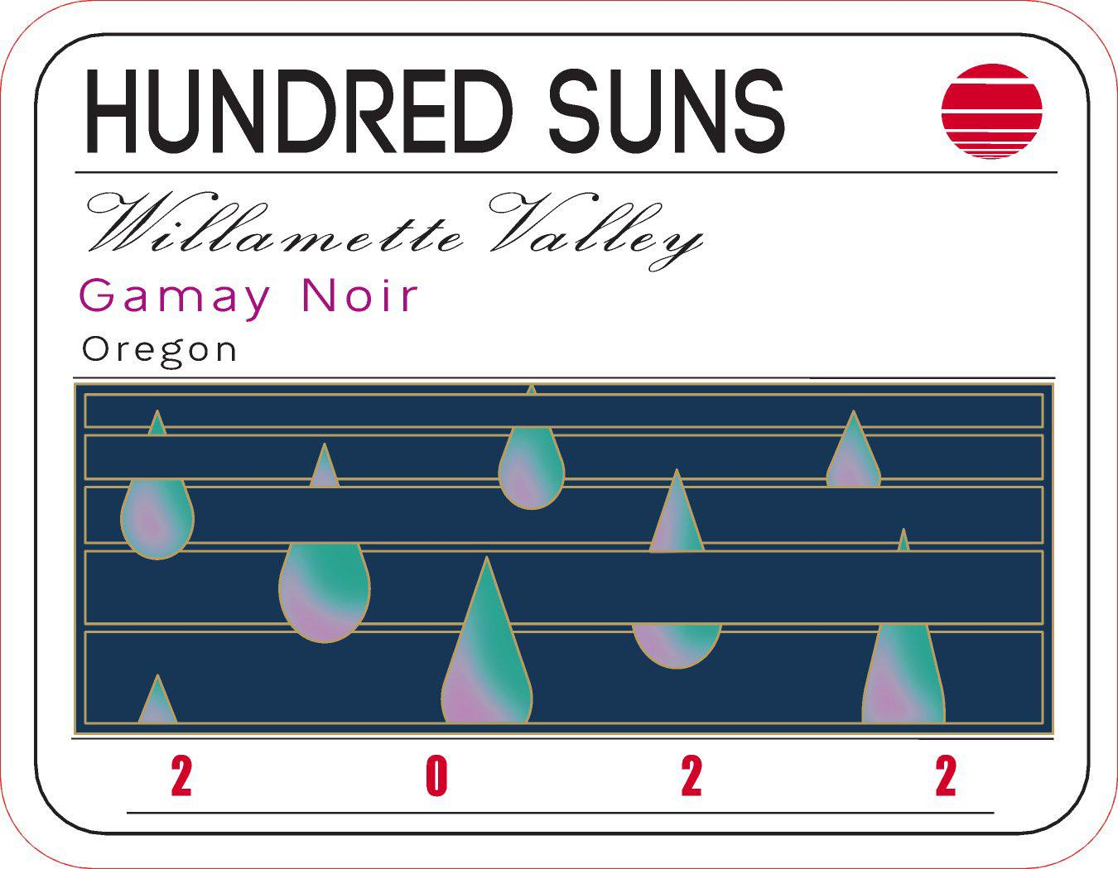

2022 Gamay Noir
Vineyards: Tualatin Estate
AVAs: Tualatin Hills AVA
Harvest Date: October 17th
Élevage: 80% French Oak , 20% Amphora
Alc/Vol: 13.%

This year's Gamay was grown at Tualatin Estate in soils mixed with deep sandstone, broken shale, clay, and basalt. Low-vigor vines set a modest crop, and the fruit was picked on October 17th. The fruit was separated into three fermentations: one fully destemmed and two lots of whole bunch. Treated in a traditional fashion, we let native yeast slowly finish fermentation. The wines were pressed and aged in a combination of 20% terracotta and 80% neutral barrels. This wine brims with spice, red cranberries, layers of perfumed licorice, and floral notes.

